1. 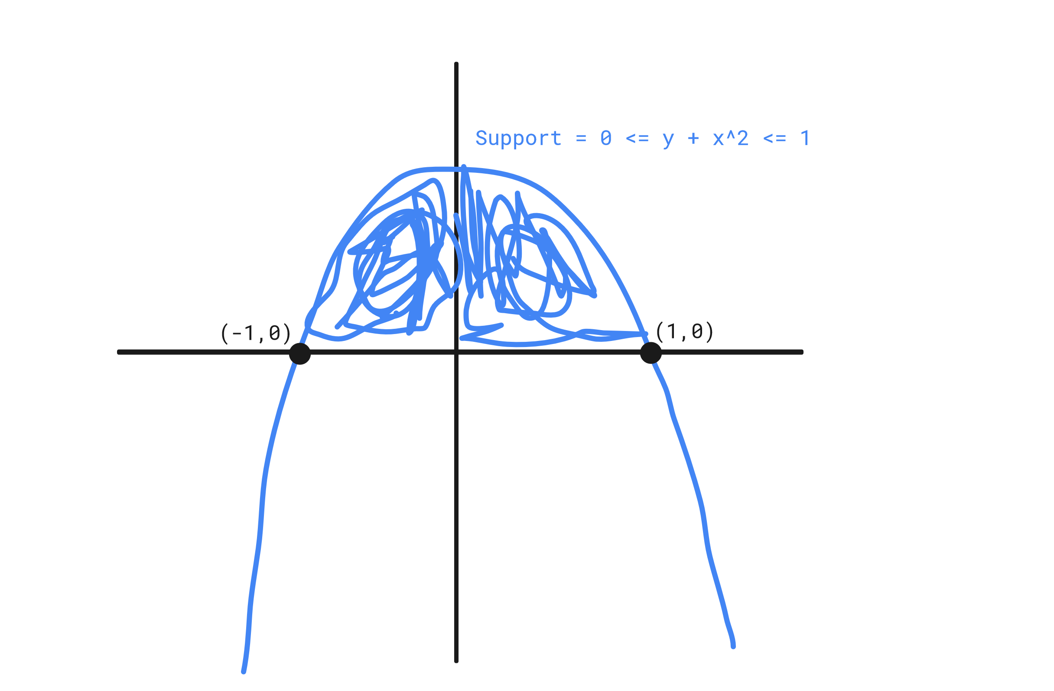
2. In order to calculate the normalizing constant we need to use the fact we know if we integrate across the support for both variables we will get 1. So: $\int_{S}{}\int_{S}{}cx^{2}dydx=\int_{-1}^{1}{}\int_{0}^{1-x^{2}}{}cx^{2}dydx=\int_{-1}^{1}{}cx^{2}(1-x^{2})dx=c\int_{-1}^{1}{}{(x}^{2}-x^{4})dx=c\frac{4}{15}=1⇒c=\frac{15}{4}$
3. To calculate the marginal PDF of X: $\int_{0}^{1-x^{2}}{}\frac{15}{4}x^{2}dy=\frac{15}{4}x^{2}(1-x^{2}) for -1≤x≤1$

To calculate the marginal PDF of Y: $\int_{-\sqrt{1-y}}^{\sqrt{1-y}}{}\frac{15}{4}x^{2}dx=\frac{15}{4}[(\frac{1}{3})(1-y)^{\frac{3}{2}}+(\frac{1}{3})(1-y)^{\frac{3}{2}}]=\frac{5}{2}(1-y)^{\frac{3}{2}} for 0≤y≤1$

These are the same marginal PDFs as those provided in the quiz, thus proving they are correct.

1. They are not independent because if they were then multiplying the two marginal PDFs would result in the original PDF, however if we do that here we get: $\frac{15}{4}x^{2}(1-x^{2})*\frac{5}{2}(1-y)^{\frac{3}{2}}=\frac{75}{8}x^{2}(1-x^{2})(1-y)^{\frac{3}{2}}⇒\frac{75}{8}x^{2}(1-x^{2})(1-y)^{\frac{3}{2}}≠\frac{15}{4}x^{2}$

Given the two equations are not equal, X and Y must not be independent in this joint distribution.